Ash Wednesday
10 February 2016
11:30am & 7:00pm

T T T
Stand
Opening Hymn Jesus Sinners Doth Receive LSB 609 vv.1-4
The sign of the cross may be made by all in remembrance of their Baptism.

P In the Name of the Father and of the Son T and of the Holy Spirit.
C Amen

P Dear brothers and sisters of our Lord Jesus Christ, on this day the Church begins a holy season of prayerful and penitential reflection. Our attention is especially directed to the holy sufferings and death of our Lord Jesus Christ.
From ancient times the season of Lent has been kept as a time of special devotion, self-denial, and humble repentance born of a faithful heart that dwells confidently on His Word and draws from it life and hope.
Let us pray that our dear Father in heaven, for the sake of His beloved Son and in the power of His Holy Spirit, might richly bless this Lententide for us so that we may come to Easter with glad hearts and keep the feast in sincerity and truth.
P O Lord, who did come to call sinners to repentance,
C Call sinners still that they may return to You and live.
P Be merciful to sinners who have nowhere to hide from Your wrath;
C Who have not loved You above all things nor have loved their neighbors as themselves.
P Soften the hearts of the impenitent;
C Restore those who have fallen away.
P Set free the sinner from his guilt and shame;
C Bring into Your light all that is hidden that You may forgive us sinners.
P We have erred and strayed from Your ways like lost sheep.
C We have followed the desires of our hearts and offended against Your law.
P We have done those things which You forbid
C And we have not done the good which You command.
P O Lord, have mercy on us.
C Spare us sinners, who confess to You our faults.
P Restore the penitent according to Your promise;
C Grant to us full pardon and remission of all our sins
P For the sake of Jesus Christ and for His merits alone.
C Look not upon our unworthiness but upon Christ our Savior.
P Fill us with the grace of Your Holy Spirit
C That we may repent of our sins and amend our sinful ways.
P Return to the Lord, Your God, for He is gracious and merciful;
C Slow to anger and abounding in steadfast love.
P Dust you are and to dust You shall return;
C But even in ashes and dust we have hope in Christ.
P As you believe, so let it be. As a called and ordained servant of Christ and by His authority, I forgive your all your sins in the name of the Father and of the Son T and of the Holy Spirit.
C Amen.

Hymn Jesus Sinners Doth Receive LSB 609 vv.5-7

Collect of the Day
P Let us pray. O God, You desire not the death of sinners, but rather that they turn from their wickedness and live. We implore You to have compassion on the frailty of our mortal nature, for we acknowledge that we are dust and to dust we shall return. Mercifully pardon our sins that we may obtain the promises You have laid up for those who are repentant; through Jesus Christ, Your Son, our Lord, who lives and reigns with You and the Holy Spirit, one God, now and forever.
C Amen.

7:00pm Choir Jesus Died Alone

Old Testament Exodus 12:1-14
P This is the Word of the Lord.
C Thanks be to God.

Psalm 51
P Have mercy on me, O God, according to Your steadfast love;
C according to Your abundant mercy blot out my transgressions.
P Wash me thoroughly from my iniquity, and cleanse me from my sin!
C For I know my transgressions, and my sin is ever before me. Against You, You only, have I sinned and done what is evil in Your sight, so that You may be justified in Your words and blameless in Your judgment.
P Behold, I was brought forth in iniquity, and in sin did my mother conceive me.
C Behold, You delight in truth in the inward being, and You teach me wisdom in the secret heart.
P Purge me with hyssop, and I shall be clean; wash me, and I shall be whiter than snow. Let me hear joy and gladness; let the bones that you have broken rejoice.
C Hide Your face from my sins, and blot out all my iniquities. Create in me a clean heart, O God, and renew a right spirit within me. Cast me not away from Your presence, and take not Your Holy Spirit from me. Restore to me the joy of Your salvation, and uphold me with a willing spirit.
P Then I will teach transgressors Your ways, and sinners will return to You.
C Glory be to the Father and to the Son and to the Holy Spirit; As it was in the beginning, is now, and will be forever. Amen.

Holy Gospel
P The Holy Gospel according to St. Luke, the 22nd chapter.
C Glory be to You, O Lord.
Luke 22:1-13
P This is the Gospel of the Lord.
C Praise be to You, O Christ.

Hymn of the Day My Place is with You, Jesus Said
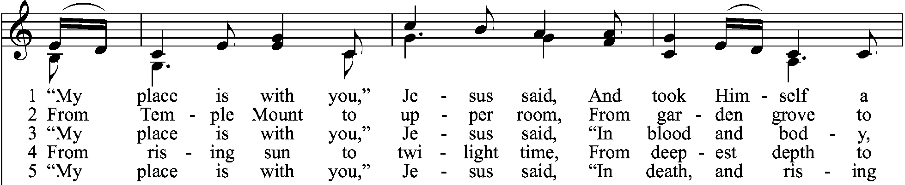
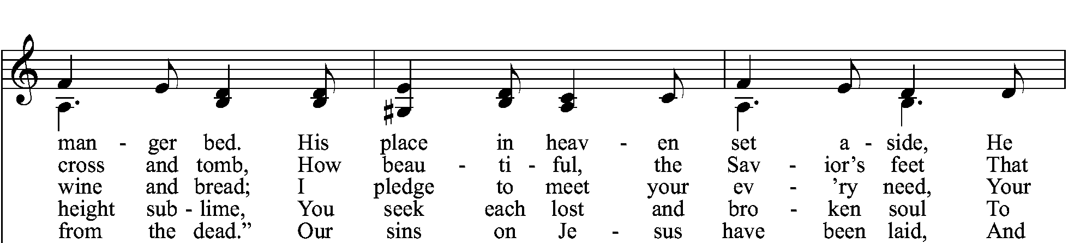
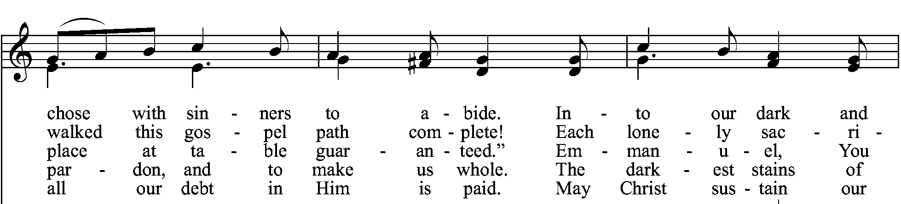
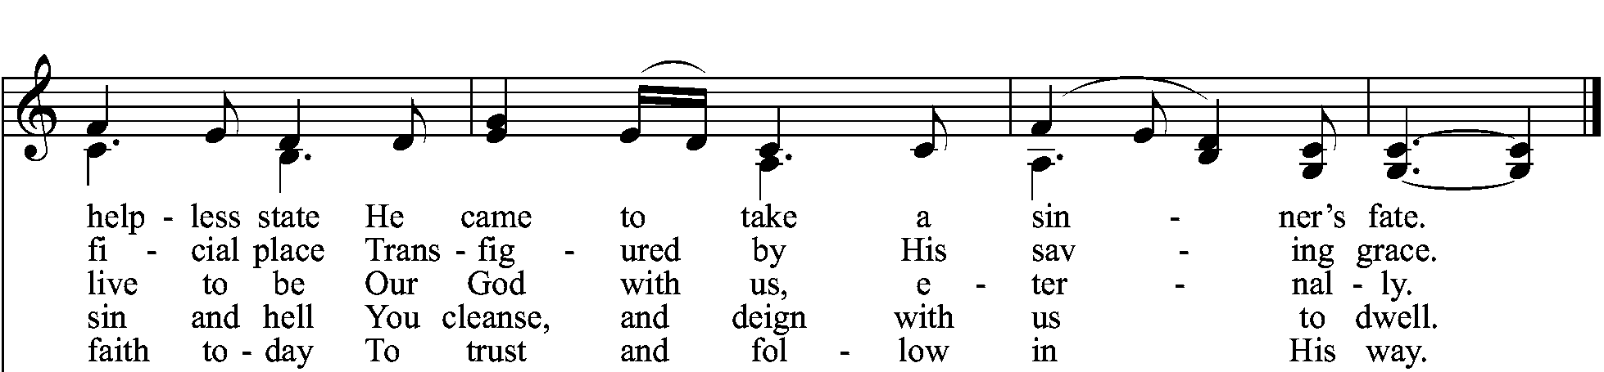

Sermon “A Place at the Table for You”
Prayer of the Church
P O Holy Redeemer, to You we lift our prayers and raise our supplications; Lord, in Your mercy,
C Hear our prayer.
P Deliver us from pride and from arrogance, lest we fail to acknowledge our sins and confess them; Lord, in Your mercy,
C Hear our prayer.
P Deliver the world from the enemies of peace and from injustice and give us good and faithful leaders to protect the weak and promote virtue; Lord, in Your mercy,
C Hear our prayer.
P Deliver Your church from her enemies and bless the pastors and church workers who serve us in Your name with Your Word. Lord, in Your mercy,
C Hear our prayer.
P Deliver the sick from their afflictions, the suffering from their pain, and the grieving from their sorrow; Lord, in Your mercy,
C Hear our prayer.
P Deliver the erring from their error, the doubting from their uncertainty, and the wandering from their ways, and return them to Your Church. Lord, in Your mercy,
C Hear our prayer.
P Deliver us from the terror of death and the victory of the grave. Lord, in Your mercy,
C Hear our prayer.
P Deliver us from selfish desire, from the tyranny of things, and from the wasteful use of all the resources You have entrusted to our care. Lord, in Your mercy,
C Hear our prayer.
P Deliver us from ingratitude for all Your mercies new every morning and restore our hearts to hope and joy in Christ our Savior. Lord, in Your mercy,
C Hear our prayer.
P Almighty God, when Your people suffered from slavery, You gave them a foretaste of freedom; when Your children wandered in the wilderness, You fed them with the bread of angels; and when Your disciples were caught in deadly conflicts, You prepared for them the Passover.
Be with us now, as we follow Your Son through the places of His Passion. Open our eyes to see His acts of love, our ears to hear His words of grace, and our hearts to trust that, in all places, He has prepared a table for us. Through Your Son, Jesus Christ, our Lord, who lives and reigns with You and the Holy Spirit, one God, now and ever.
C Amen.
P Lord, remember us in your kingdom, and teach us to pray:

Lord's Prayer
The Words of Our Lord
Pax Domini
P The peace of the Lord be with you always.
C Amen.

Distribution
Jesus, Thy Blood and Righteousness LSB 563
I Come, O Savior, to Thy Table LSB 618

Dismissal & Post-Communion Prayer

Benediction
P The Lord bless you and keep you.
The Lord make His face shine on you and be gracious to you.
The Lord look upon you with favor and T give you peace.
C Amen.

Closing Hymn Jesus, Refuge of the Weary LSB 423

Offering: If you have brought an offering, it can be placed in the plates near the exits.
